File permissions in Linux

Project description

"Performed Linux file permission management using command-line utilities to inspect, analyze, and modify access permissions for regular files, hidden files, and directories. Applied the chmod command to enforce access restrictions and improve basic system security."

Check file and directory details
Command: ls -la
ls -l: command shows permission of files and directories. ls -a: command show hidden files. So, combining them we get ls -la where permissions of hidden files are also viewable This command is used because permissions of normal files, directories and hidden files are required.
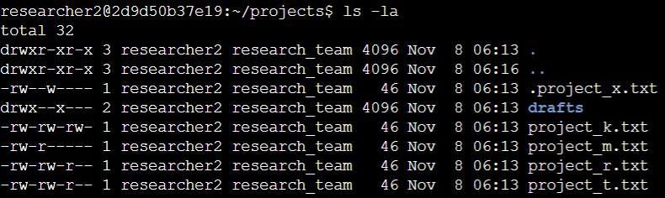

Describe the permissions string

In the /home/researcher2/projects directory, there are five files. Choosing one example to explain the permission string:
r means read, w means write and x means execute

● project_k.txt: -rw-rw-rw-
First string (-): represent the type of file. If it is a hyphen, it is a file and if it is a d then it is a directory
Then next 3 string (2-4 string place): defines what permissions user have: here rw- is present which means user have read, write permission but don’t have execute permissions.
If a user has execute permissions, then instead of – it will be ‘x’ string

5-7 string places: defines the permissions what group has. In this file it has rw- permission that is read and write permissions are given but no execute permission.

8-10 string place: defines the permission what other (refers to other users who have access to the computer minus the main user) has. In this file it has rw- permission that is read and write permissions are given but no execute permissions are given.

Change file permissions
TASK: other than user no one should have write permissions
COMMAND: chmod g-w,o-w project_k.txt
In the image only we can observe before after running of command. It is observed that in project_k.txt file
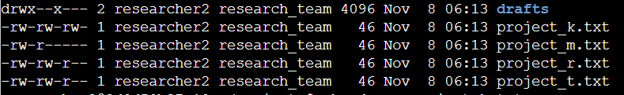
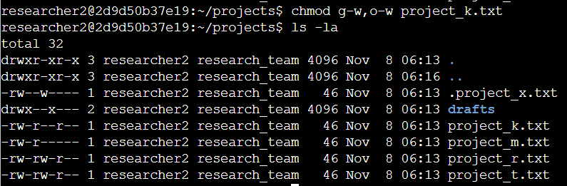

Change file permissions on a hidden file
OBJECTIVE: removing write permissions of user and group and adding read permission of group

COMMAND: chmod u-w,g-w,g+r .project_x.txt

Hidden Files: files which start with “.” And can’t be viewed using ls -l command. To view hidden files, we can use either ls -a or ls -la command.
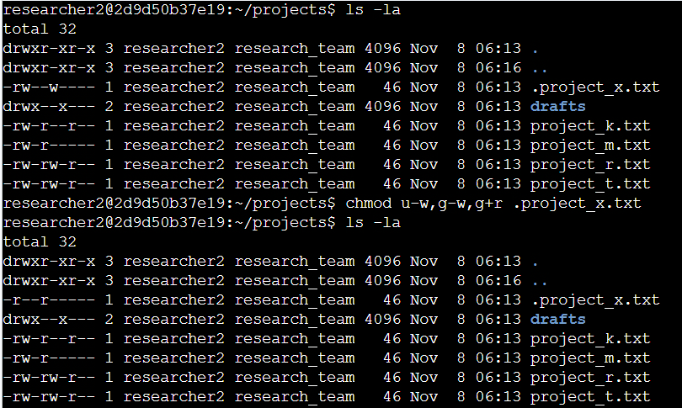

Change directory permissions
OBJECTIVE: removing execute permission of group from drafts directory so that only user has the permission to execute, directory execute permission means the ability to traverse or access the directory
COMMAND: chmod g-x drafts/
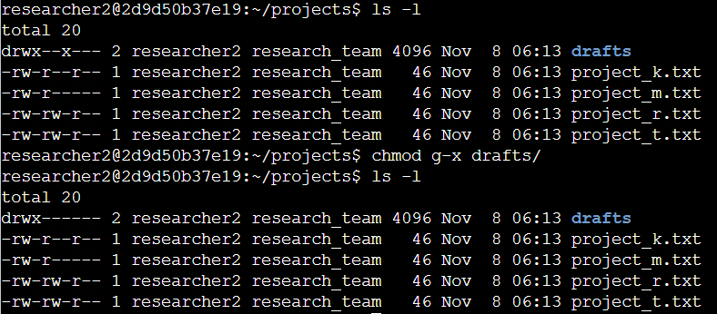

Summary
Till now all the commands we executed, we can understand what are the permissions a file or directory has, which type of user does have access. There are three types of permissions: READ, WRITE and EXECUTE. There are 3 types of user categories: USER, GROUP and OTHER. We can even change the permissions according to the preference to which type of user group has what type of permissions. Also from the security purpose view these are very important as to reduce security risks we remove permission types of other and group users.

